

To: Professor Osama Alshaykh and Professor Alan Pisano

From: Caroline Jones, Sneha Pradhan, Michael Haley, Tanatsigwa Hungwe, and Zehua (Harry) Zhao

Team: 1

Date: April 4th, 2017

Subject: **Luminesense System Functional Deliverable Test Report**

**___________________________________________________________________________________________**



1. **Project Objective**

1.1 Team Luminesense seeks to revolutionize the way that people interact with lighting fixtures in rooms. The project’s primary motivation is to provide an intelligent, gesture based lighting system that provides customizable, convenient, and energy efficient control over these fixtures.

**2.0 Test Objective and Significance**

2.1 This functional test demonstrated the final product that will be integrated into the customer’s

existing systems. This test represented an end-to-end demonstration of all the methods

and tools designed to fulfill the requirements set by the customer. The test focused on two

specific use cases - when the user has access to the wearable device and when they do not. The

test plan showcases all the latest improvements in the Luminesense system design as well as the

advantages the latest design has over existing solutions.

2.2 **Luminaire Selection**

The “luminaire” is a device provided by the client. It is a powerful light emitting diode which emits a light code that is uniquely identifiable by its frequency. The luminaire is driven by a Particle Photon. The proposed Luminesense system design will have an array of 16 luminaires and in order to interact with them, the system needs to be able to distinguish amongst them. To do so, the system must be able to sample and decode these light codes. For this purpose, a photodiode amplifier circuit was attached to the Arduino 101. Additional peripherals were integrated into the circuit: three buttons. In addition to the hardware setup, a “luminaire map” was designed to differentiate and locate all the luminaires in the room.

The following arrangement models the basic functionality of the wearable device: The

photodiode samples analog light signals, and subsequently, Arduino determines the frequency of

the light signals and hence, determines the light chosen. The buttons are responsible for

controlling or manipulating aspects of the system interaction. The white button - the “Session

controller”, is responsible for controlling the session of interaction between the user and the

system. The green button - “Selection controller”, is responsible for selecting the desired

luminaires. The red button - “IMU controller”, responsible for ending the selection phase, and

activating the transmission of IMU data (i.e. the desired gestures). Testing this component was

vital to ensure that the wearable could precisely determine light ID’s, select the corresponding

light, and relay all the necessary information to the Raspberry Pi. This test case helped ensure

that the user could accomplish editing the lighting fixtures in a satisfying experience. Shown

below in Figures 1 and 2 are the photodiode amplifier circuit with the three buttons and the

luminaire map.

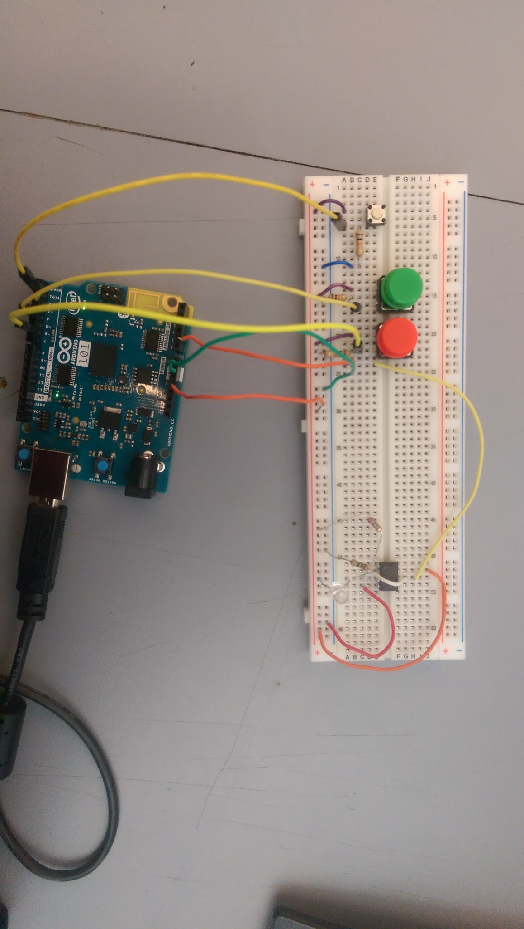

*Figure 1: Photodiode Amplifier circuit with peripherals*

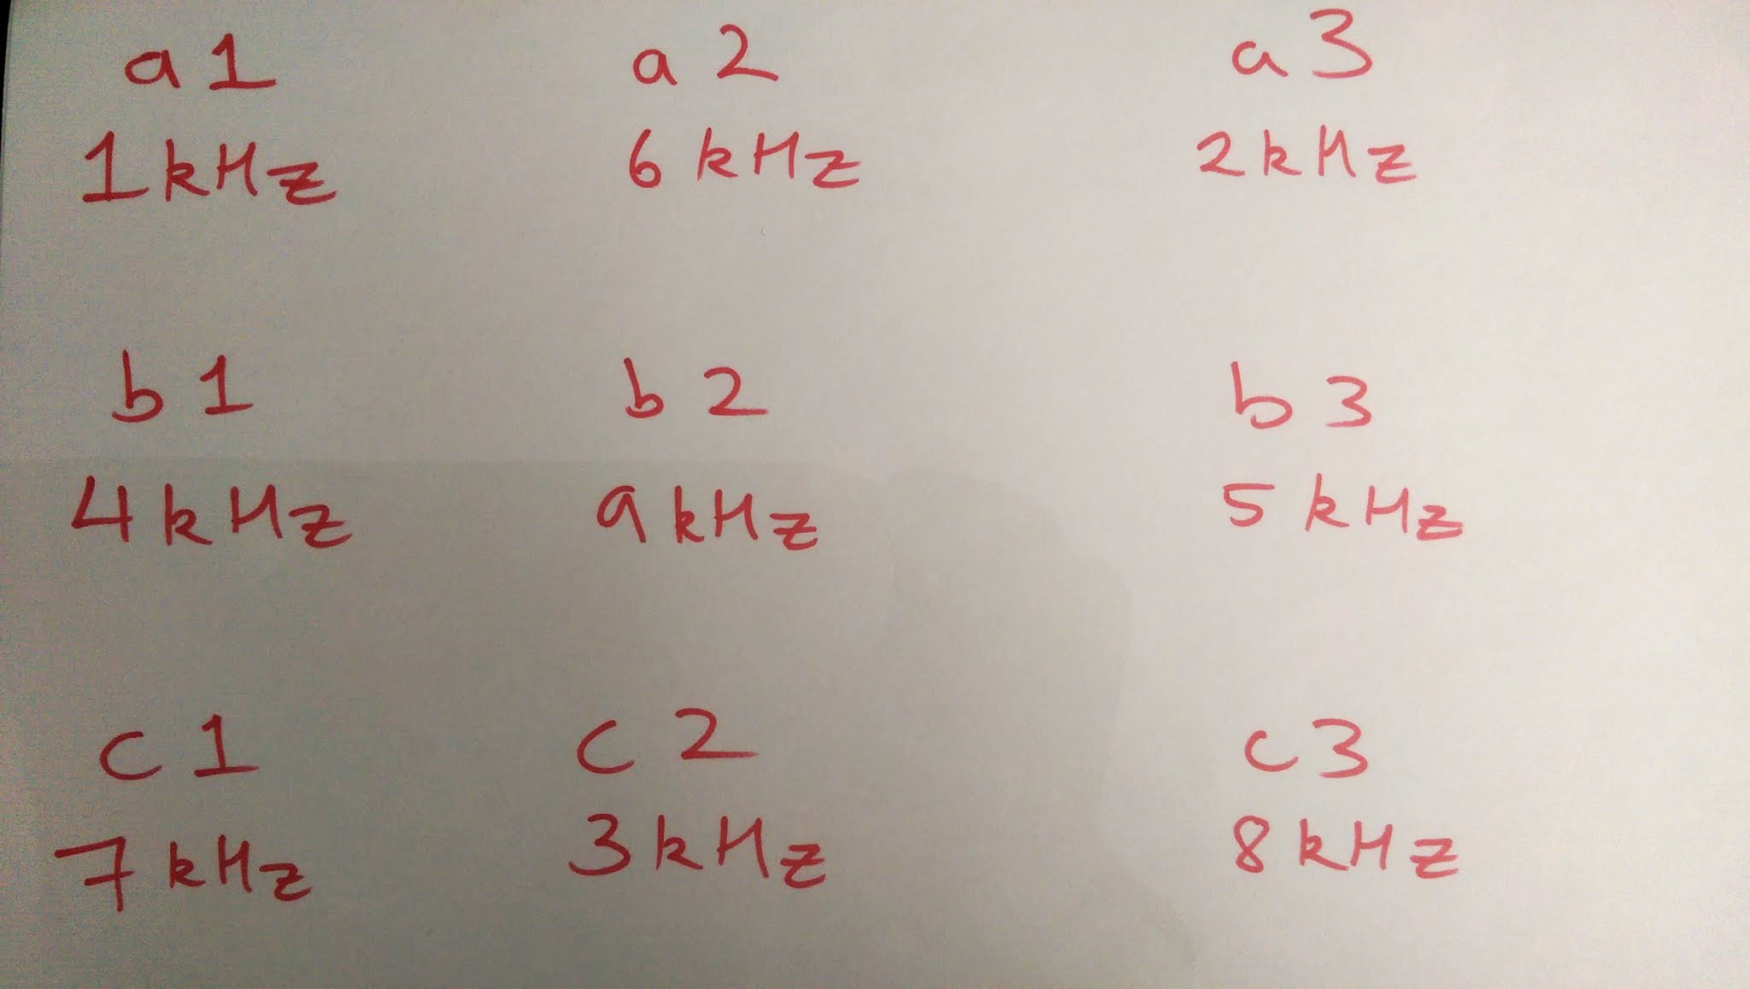

*Figure 2: Luminaire map*

2.3 **Gesture Mode**

Luminesense’s approach to solving the client’s problem involves separating the modes of

engagement into two distinct parts: “gesture” and “adaptive” mode. The former allows the user to

explicitly interact with the system by invoking gestures through the wearable; the latter

automatically controls the lights when the wearable is disconnected or a user leaves or enters the

room. The gesture mode gives users explicit control over lights through the wearable and command library. Aspects of the gesture mode is controlled by three buttons - The “Session controller”, the “Selection controller” and the “IMU controller”. The first button is used to alternate between the gesture and adaptive mode via session controls. The second selects the desired lights, whilst the third activates the IMU. During gesture mode, the wearable sends various information regarding the light ID’s and the gesture data to the Raspberry Pi. The Raspberry Pi acts as the central base, collecting and aggregating the data received. The data is then parsed and forwarded as a command to the Particle Photon. Upon receiving this command, the Photon on the appropriate luminaire alters its state accordingly. Shown below in Figure 3 is the block diagram of the gesture-control mode. The inputs to the system are the user’s gesture, driven by an IMU on the wearable, and the frequency modulated light, driven by the luminaire. These inputs go to the wearable, which determines the light ID and sends its gesture information via Bluetooth Low Energy to the Raspberry Pi. The Raspberry Pi determines the gesture and sends a valid command to the Photon over Wi-Fi, which changes the state of the selected luminaire(s) accordingly. This test case helped ensure that the user could accomplish editing the lighting fixtures when the system was engaged in “gesture mode” Additionally, the test helped investigate and showcase the typical response time of the Luminesense design - a low latency light fixture editing system.

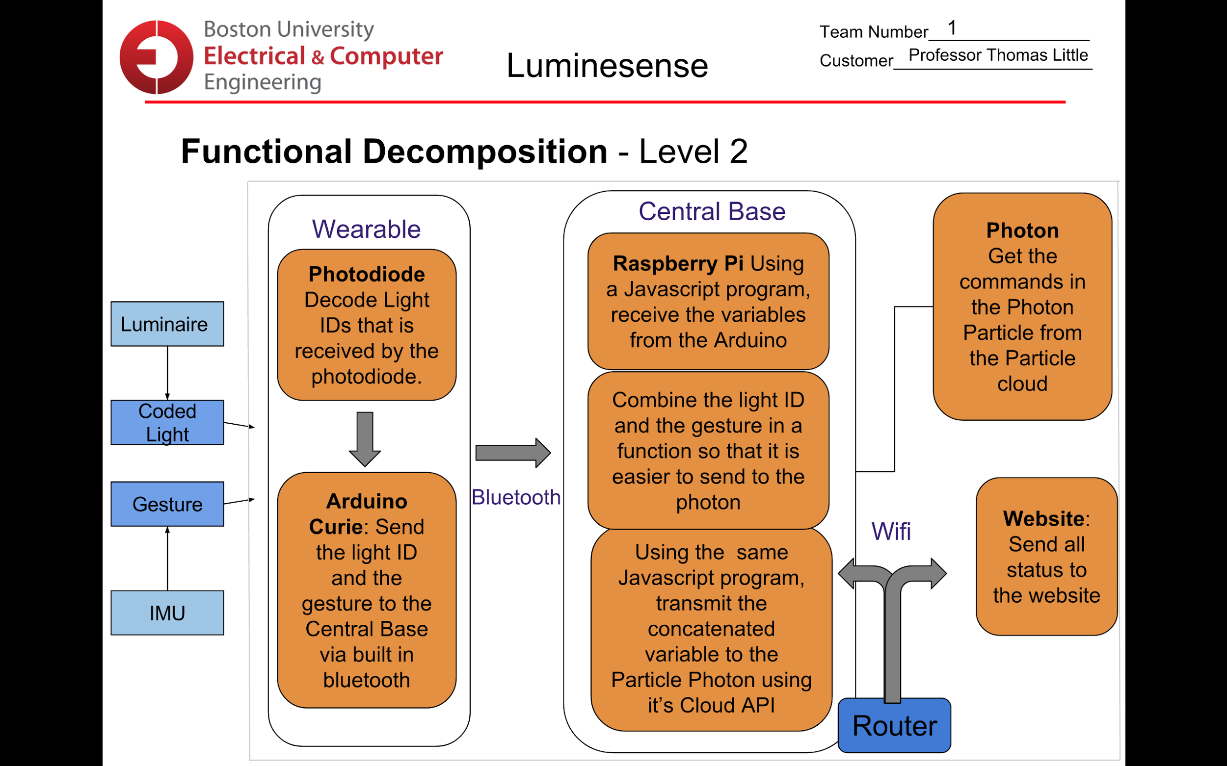

*Figure 3: Gesture Mode*

2.4 **Adaptive Mode**

An additional requirement set by the client is a system that will respond and interact with users

even when a wearable is not present. The solution for this is an “adaptive mode” - that detects the

presence (or absence) of occupants in the environment and updates the luminaires accordingly.

Adaptive mode is invoked using twelve single pixel sensors (provided by client) driven by a

Raspberry Pi. In order to successfully implement the adaptive mode, the thermal data collected

by these sensors needs to be sampled and analyzed appropriately. Furthermore, the data must be

interpreted to establish whether an occupant is present in the room or not. This deliverable

showed the ability of the system to detect real time updates of the single pixel readings, and formulate decisions based on the status of the room i.e. to change the state of the lights when necessary.

2.5 **Website Application**

The website application that accompanies the luminesense system is currently live at

[luminesense.herokuapp.com](http://luminesense.herokuapp.com/). This serves as a portal for the user to interact with their system.

The application serves two purposes: energy usage reporting to users and remote control over the

system (e.g. customize the gesture library). The energy usage graph displays the energy usage of

the system over time, with kilowatt-hours on the vertical axis (y-axis) and time on the

horizontal axis (x-axis). Using this, users can track their energy usage over time. Users can also

issue commands to luminaires on the system through the web application, and change their

gesture preferences for commands. This allows the user to interact with the luminaires if their

wearable is not operable for some reason. Through the testing of the web app, we show how the

user can interact with and customize their system. The test also shows that the user is able to

gather energy information about their system, and control their system in the event that they do

not have access to their wearable device.

2.6 **Wearable Design**

The focus of the wearable design is to test the safety and the battery life on the Arduino 101 board. The battery should prevent the possibility of short circuiting when the voltage from the battery is too low. The battery should also provide a stable current for the Arduino 101 for a reasonable period of time after fully charged. In addition to battery consumption, the customer required a wearable device, particularly one that could be worn around the wrist. A case and strap were designed and fabricated in order to accomplish this. All the tests and simulations were conducted with respect to the Arduino 101. Shown below in Figure 4 are the battery and finalized case designs.

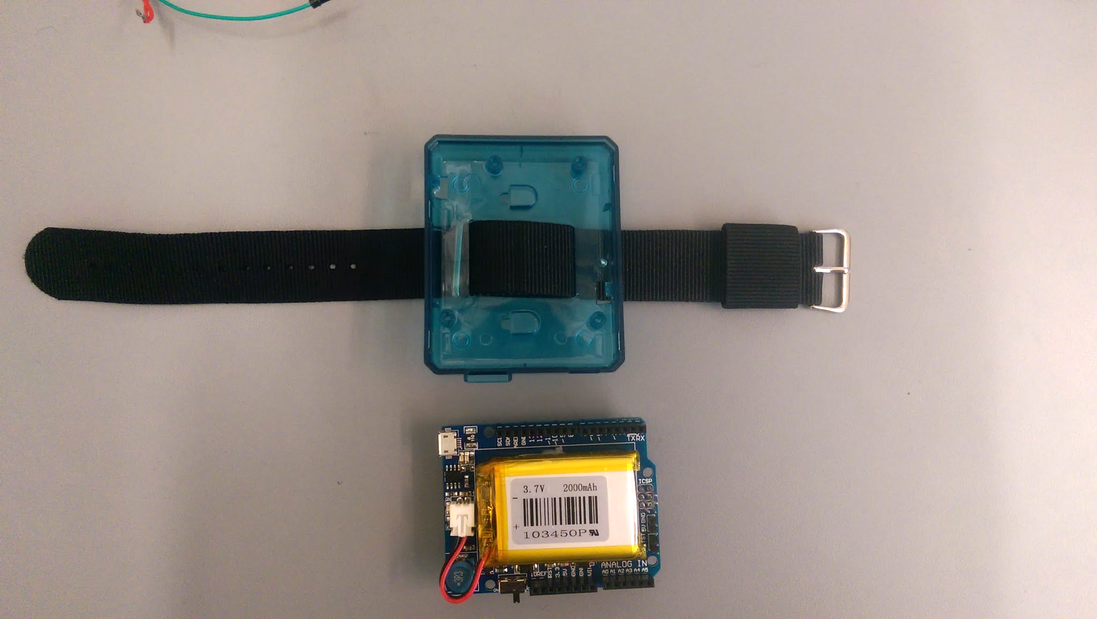

*Figure 4: Wearable battery and case*

**3.0 Equipment and Setup**

3.1 **Overall Arrangement**

The entire arrangement of components remained the same as the previous deliverables. The setup is shown in Figure 5.

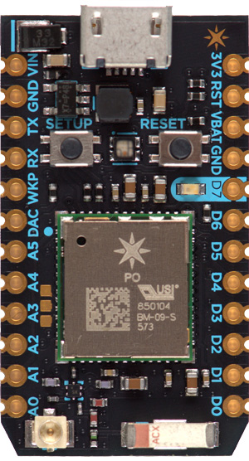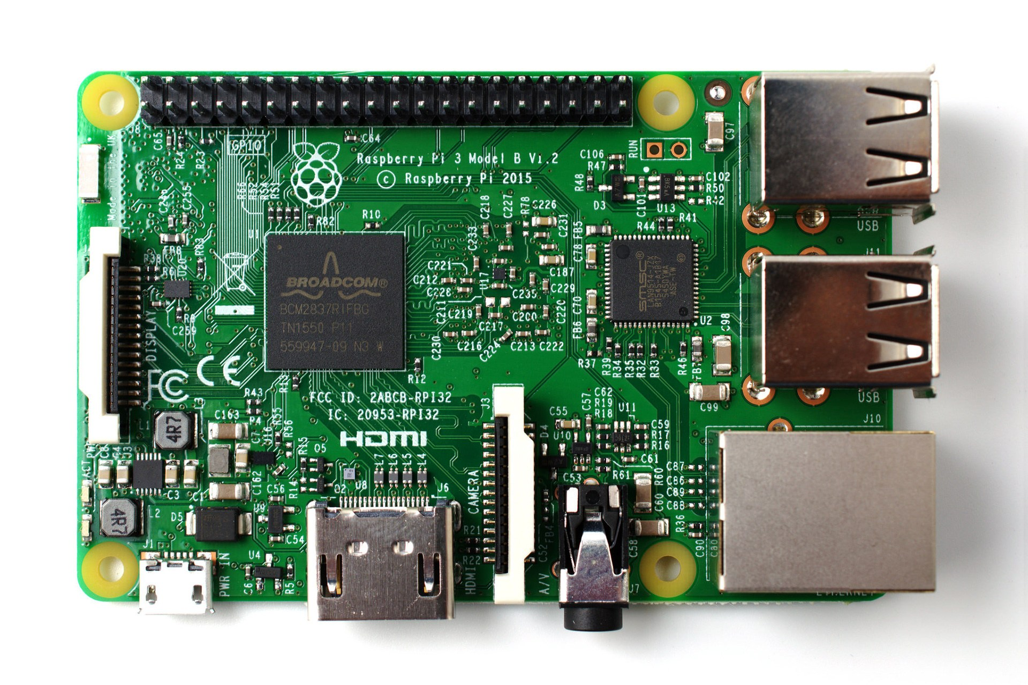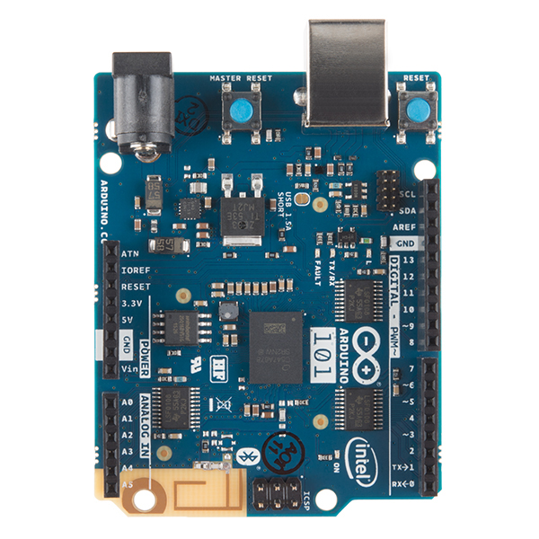

*Figure 5: The Communication Loop*

3.2 **Luminaire Selection**

Utilizing the Arduino IDE, flash the *wearable_code.ino* code onto the Arduino 101. This code executes the following instructions:

(i) Polls for “Session” button

(ii) Performs Fast Fourier Transforms (FFTs)

(iii) Polls for “Selection” button

(iv) Sends light ID’s and selection state via Bluetooth Low Energy (BLE)

(v) Polls for “IMU” button

(vi) Sends IMU data via BLE

The session button is polled on Arduino pin 2, the analog input from the photodiode is sampled at

port A1, the selection button is polled on Arduino pin 4, and the IMU button is polled on Arduino

pin 6. The session button has two states: “Begin” and “End”. These states are sent as ASCII

values via BLE to the Raspberry Pi as a result of button pushes. Within the “Begin” state,

readings from the photodiode are then aggregated to determine the frequency of the light source

using FFT. This involves dividing the sample rate of the ADC into 128 bins/bands of frequency

to pinpoint the amplitudes of sampled light (The highest amplitude indicating the light source

being observed by the system). Using mathematical operations (multiple samples and additional

median calculations), the frequency, and hence the ID (ranging from 1 - 9) is determined by

multiplying the sampling rate by the bin number. The following method is provided by

customized FFT functions. Furthermore, the light ID’s are sent to and received by the Raspberry

Pi for processing (conversion of integer ID’s to device ID’s for Particle API calls). Subsequently,

the selection button adds the given device ID into an array of selected luminaires. And finally, the

IMU button ends the selection phase and implements gestures on the selected luminaires. Using

the luminaire map and the console, the light sources observed, selected and edited are then

monitored for verification.

3.3 **Gesture Mode**

As mentioned earlier, the systems’s “gesture mode” is controlled by the Session controller (the white button). The state of the Session controller determines whether “gesture mode” is active or not. In the “Begin” state, all the luminaires are sent to a flux state - a lime green color - where they can be managed/edited in any desired way. During this state, the luminaires are selected and commands are implemented and executed. In the “End” state, all edited luminaires persist with their chosen settings and arrangement, whereas all the unchanged luminaires are shut off. The gesture library remained the same since the last deliverable. Therefore only four gestures were available: “light on”, “light off”, “red” and “blue”. Using the Serial Monitor and ground-truth observations, all the luminaires selected and edited during “gesture mode” interactions are monitored for verification.

3.4 **Adaptive Mode**

The “adaptive mode” is driven by the 11 single pixel sensors located in the SLURP lab. These sensors are indexed 0 -11 (excluding 4) and each take a snapshot of the sensor area’s RGBW image approximately 10 times per second. A Raspberry Pi Model B mounted in the lab receives the thermal data from the sensors. Once the Raspberry Pi has initialized the sensor driver, the thermal data streamed onto the Pi for analysis. An algorithm implemented in Python on the Pi keeps track of recent data “states”, checking for changes that signify new entrants seen by specific single pixel sensors. If the data stream remains constant, then either the room is empty or there has been no movement for a period of time. An MQTT machine-to-machine networking protocol is used to interact with the Raspberry Pi from a local machine connected to the lab’s network via a thunderbolt. In the future, the detection of these sensor state changes can be used to alert the system when people walk into the room, or to implement a time-out that turns the lights off when there has been persistent inactivity for several minutes.

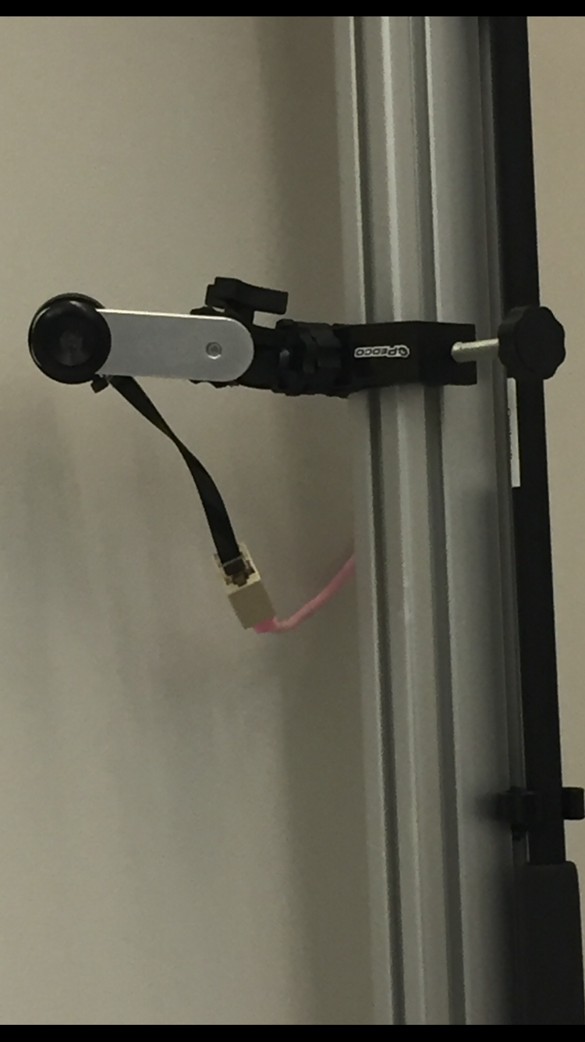

*Figure 5b: A Single Pixel Sensor driving Adaptive Mode*

3.5 **Website Application**

The website can be found at [luminesense.herokuapp.com](http://luminesense.herokuapp.com/). There are three pages to the website: “Dashboard,” “Energy Usage,” and “Gestures.” The “Dashboard” page explains the luminesense system and gives more background information. The “Energy Usage” page displays a graph showing the user’s energy usage over time and is accompanied by an explanation. The “Gestures” page allows the user to interface with the system by issuing commands to luminaires and changing their gesture preferences for each command. The test focused on the “Gesture” and “Energy Usage” pages. When navigating to the “Energy Usage” page, the web app pulls data regarding the energy usage from a database. The database is updated by the Raspberry Pi, logging the number of active luminaires. This information is gathered, interpreted into a comprehensible energy usage report for that day, and pushed to another table in the database. This is what the web app pulls and displays on the graph. The “Gestures” page has two different functionalities that each work a bit differently. Selecting a command to issue to the luminaires triggers a Particle cloud API to the Photons driving the luminaires. This way, the web application can control the luminaires in the same manner that the gestures do. Gesture command preferences are stored in a table in the database, and get updated if a user interacts with this portion of the “Gesture” page. The user may choose their preferred gesture to correlate with the respective action.

3.6 **Wearable Design**

The wearable design setup includes the Arduino 101 itself attached to the battery shield breakout board. Proto Shields, a breakout breadboard that can be attached to the arduino is mounted on top of the Arduino, where the photodiode and buttons are placed. Finally, the entire board is mounted onto the wearable case that was manufactured to hold the Arduino board. The case has a wristband that can be adjusted to any size. After turning on the battery, the user will be able to use wearable device as a wireless controller that can perform the gesture commands to luminaires.

**4.0 Measurements and Data**

3.1 **Luminaire Selection**

During the testing of the Arduino, the light signal data was sampled using an amplified photodiode. The FFT algorithm then analyses the signal, placing the observed amplitudes into 128 bins. Due to harmonics only 64 bins have the relevant amplitudes. The bins with the highest amplitudes are then selected as being the frequencies most likely being observed. The frequency is then calculated by multiplying the bin number by the sample rate. The frequencies are then converted to relevant ID’s (in the range 1 - 9) using a switch case. These ID’s are sent to the Raspberry Pi where the are converted to relevant device ID’s, and hence the names assigned by the luminaire map. Once the user selects the desired luminaires (via the Selection controller), a relevant signal is observed by the Pi and the luminaire is added to an array of selected luminaires. Figures 6 and 7 below shows the ID’s observed, and selected Luminaires received by the Raspberry Pi (viewed on the Pi’s console).

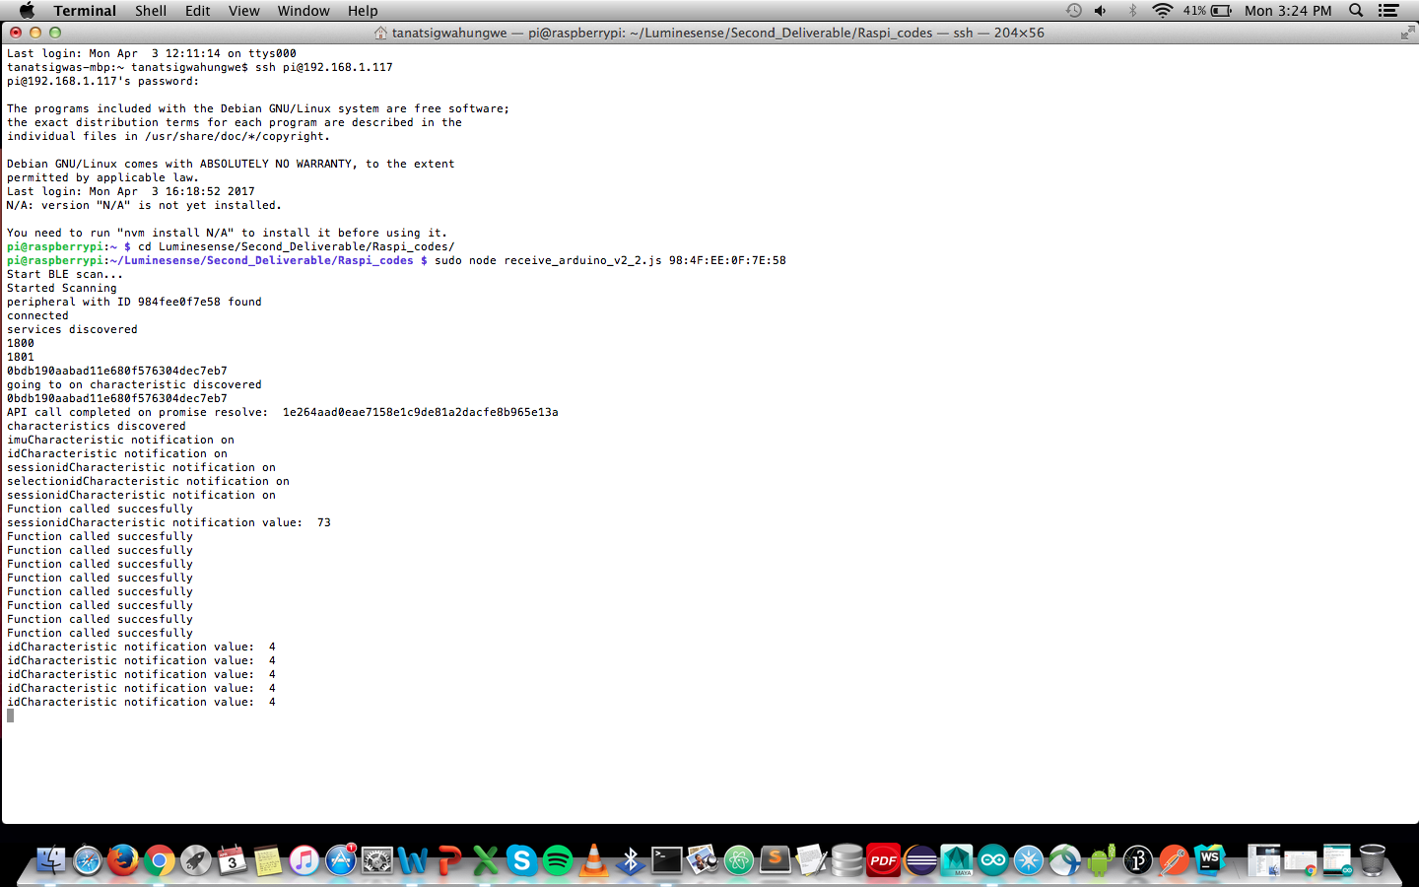

*Figure 6: The Pi console - ID’s*

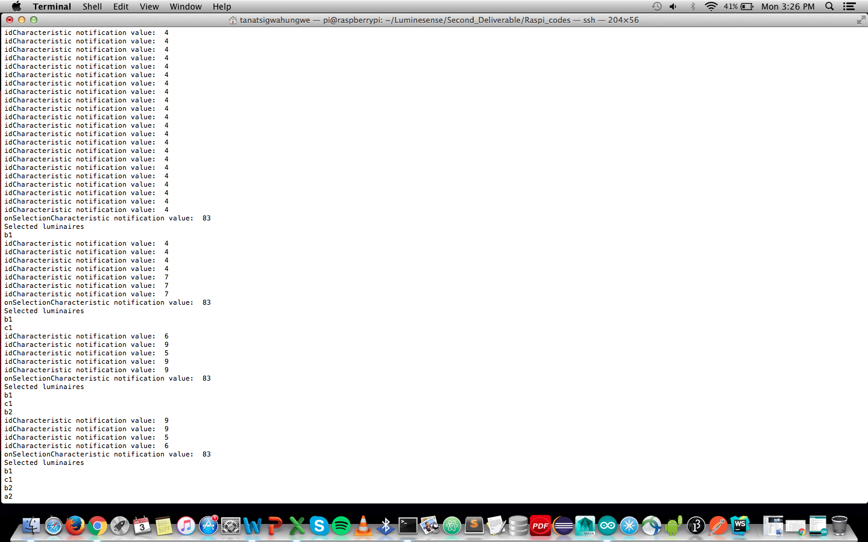

*Figure 7: The Pi console - selected Luminaires*

3.2 **Gesture Mode**

During testing of the “gesture mode”, a session “Begin” signal was sent - signifying the commencement of active user and system interactions. Subsequently, the relevant luminaires were selected (via a “select” signal), and their device ID’s stored into a selected luminaire array. Additionally, an “IMU activation” signal was sent - marking the end of the selection procedure, and the sending of gesture data. Finally, a session “End” signal was sent - indicating the end of active user engagement with the system. All edited luminaires maintain their newfound state, whereas all unchanged luminaires shut down. Figures 8 and 9 shows the relevant signals sent from each button, the Photon device ID’s controlling the chosen luminaires, and the “flux” state of luminaires (viewed on the Pi’s console).



*Figure 8: The Pi console - Session button signals*

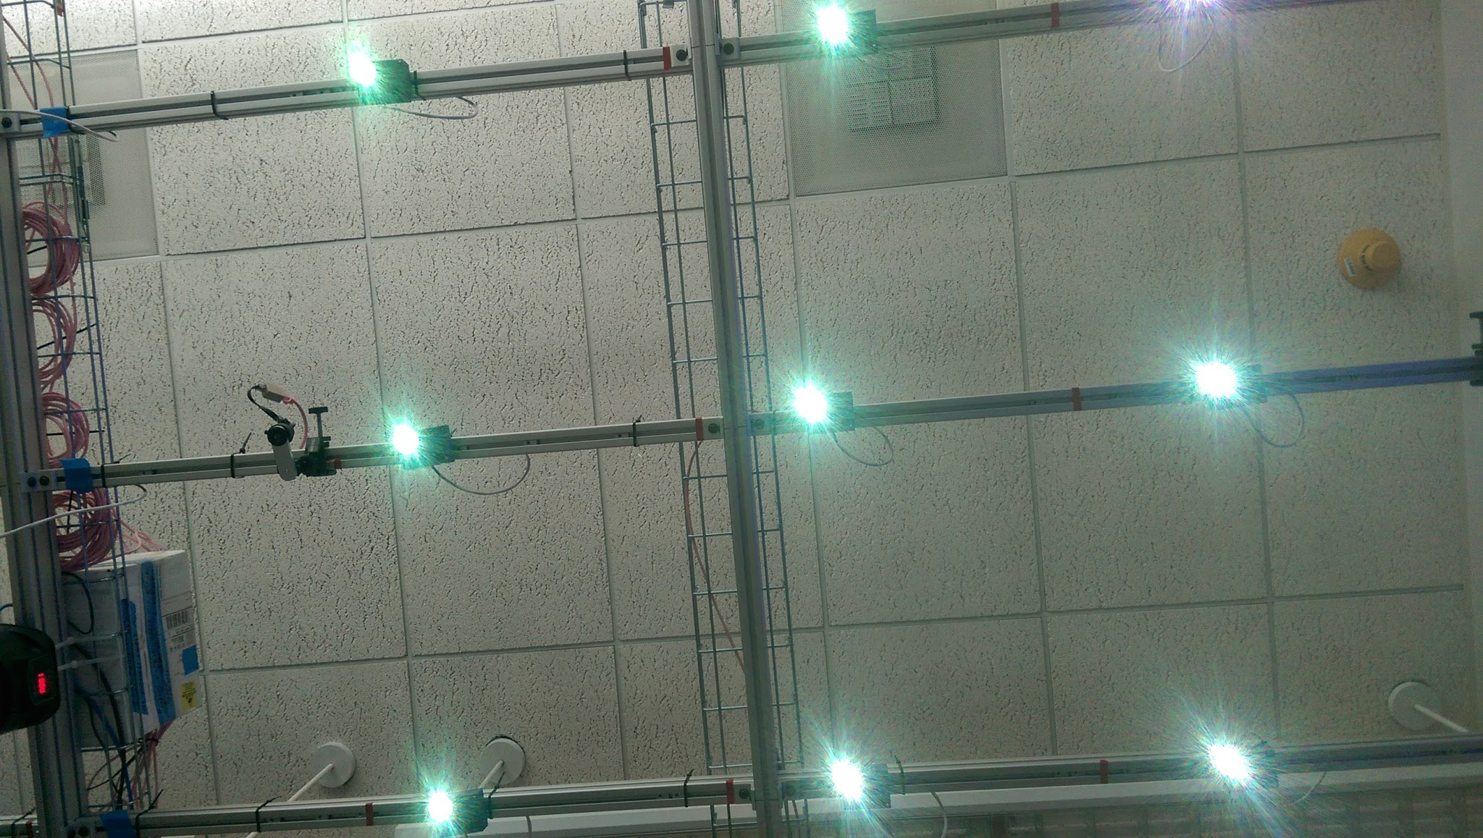

*Figure 9: Luminaire “flux” state*

3.3 **Adaptive Mode**

During the “adaptive mode” test, Luminesense team member Harry entered the (virtually)

vacant room in SLURP once the Raspberry Pi drivers had been initialized. At this point the

occupancy detection algorithm was launched and took real time sensor data (shown in figure 10) as input, and outputted a response message (Figure 10c), which indicated that a new room entrant was detected at 4/11 sensors. Two of these sensors (4 and 11) detected this occurrence twice. When the detection algorithm ran with an empty room, there was no console output (meaning 0

sensors detected a new entrant).

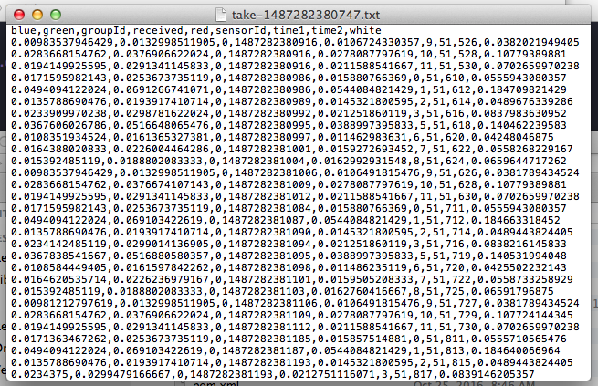

*Figure 10a: The adaptive mode thermal data used to determine occupancy presence*



*Figure 10b: The adaptive mode table in SQL database*

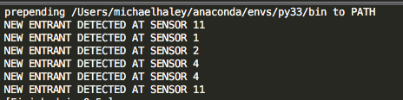

*Figure 10c: Console output from detection algorithm*

3.4 **Website Application**

The “Energy Usage” graph and the gesture customization on the “Gestures” page function mainly with the use of a database we have created. The figure below shows the tables created in the database.

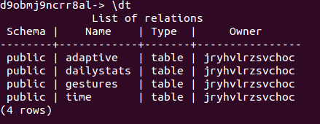

*Figure 11: All tables in SQL database*

In particular, the energy usage graph uses both the “dailystats” and the “time” tables. The time table is what gets updated by the raspberry pi whenever a luminaire is turned on and off. The dailystats table gets updated once per day and aggregates the information from the time table. The dailystats table contains the data that gets displayed on the graph.



*Figure 12: The dailystats table - denoting kW (double) and day (date)*



*Figure 13: The time table - denoting timing (timestamp) and lightson (integer)*

The output of the graph is a line graph where every point represents a date on the horizontal axis and a measurement of energy usage (in kilowatts) on the vertical axis.

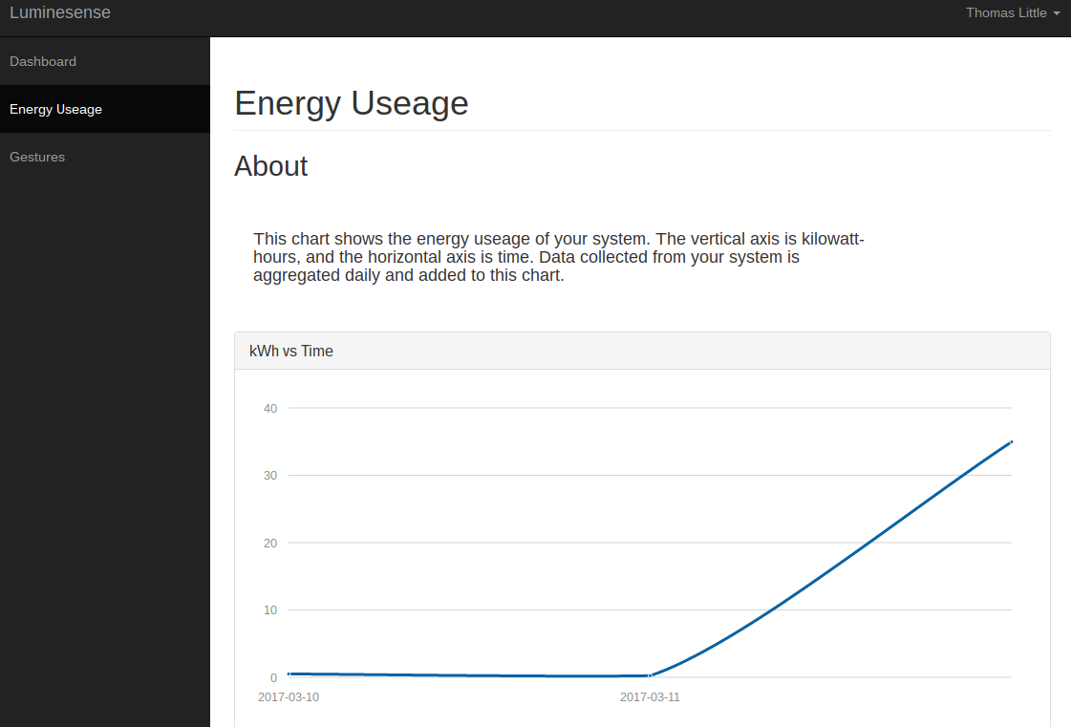

*Figure 14: The energy usage page on the web application*

The “Gestures” page contains information related to how the user can interface with the system. Here, the user is able to both issue commands to the system and update their gesture preferences. The gestures page also enables the user to issue commands to the system via the interface shown below. Any color or on/off command issued to the system will affect all of the luminaires; unfortunately there is no way for the user to precisely select which luminaires that they would like to issue this command to. The command is sent to the luminaires directly from the web app backend via the particle cloud api.

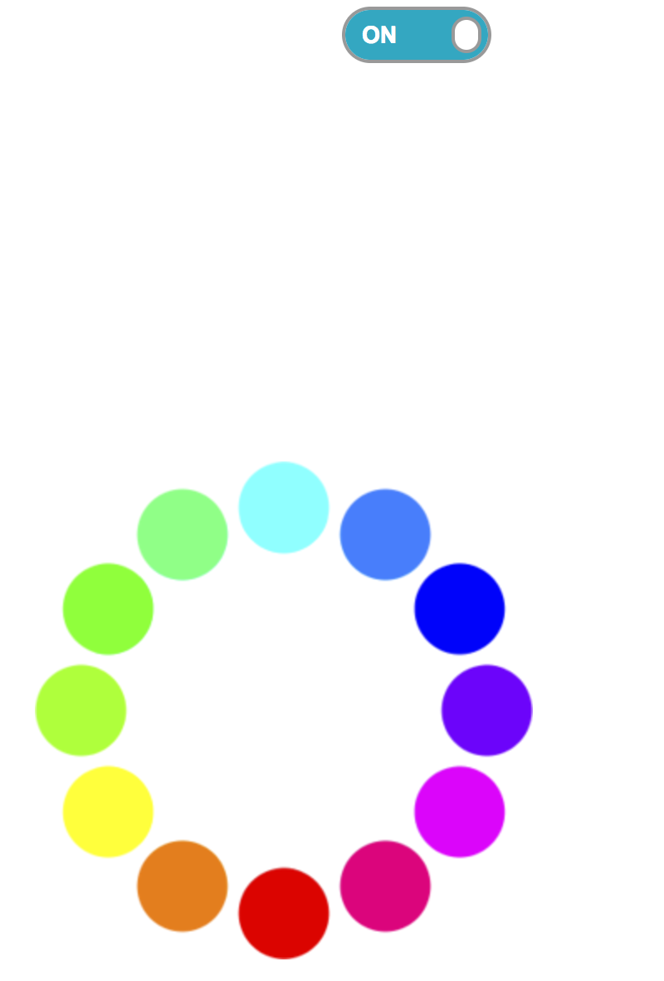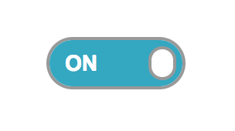

*Figure 15: The gesture control interface on the web app*

The gesture preferences are stored in the “gestures” table in the database. When the user interacts with this portion of the web app, the table gets updated.

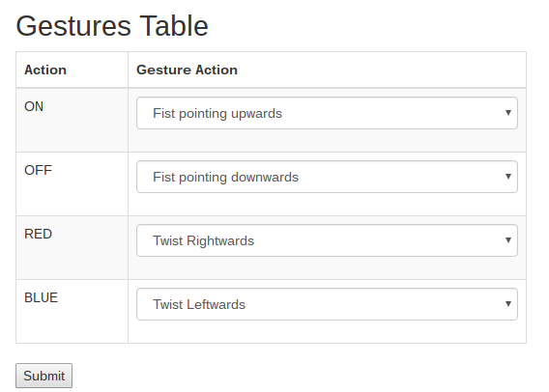

*Figure 16: The gesture preference interface on the web app*

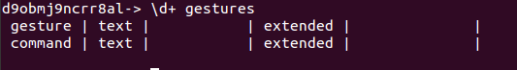

*Figure 17: The gestures table - denoting gesture (text) and command (text)*

When a user performs a gesture, the raspberry pi pulls information from this table to see what command the gesture corresponds to. The gestures are sent to the raspberry pi from the arduino 101 via a one byte ascii value. In the figure below, the raspberry pi receives the gesture with ASCII value 114. It checks the database and sees that this gesture corresponds with the command that has an ascii value of 100.

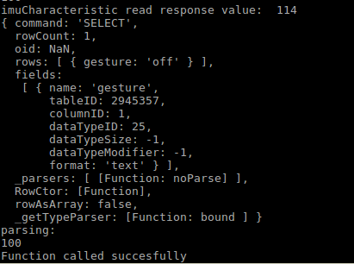

*Figure 18: Output of the raspberry pi adapting to gesture preferences from the cloud. Here, it reads a command “114” but checks the database to see that the gesture should correspond to command “100”*

3.5 **Wearable Design**

In order to test the battery life on Arduino, fully charge the battery, then connect it to an Arduino and turn on the switch and begin timing. Leave it until the LED light - which indicates battery performance on the battery shield - goes off then stop the timing. The battery life for the battery shield on Arduino is approximately 19 hrs 48 mins. The designed case appropriately fits the Arduino (in tandem with the fitted battery) as well as the user (with regards to the retrofitted watch strap). The arrangement is shown below in Figure 19.

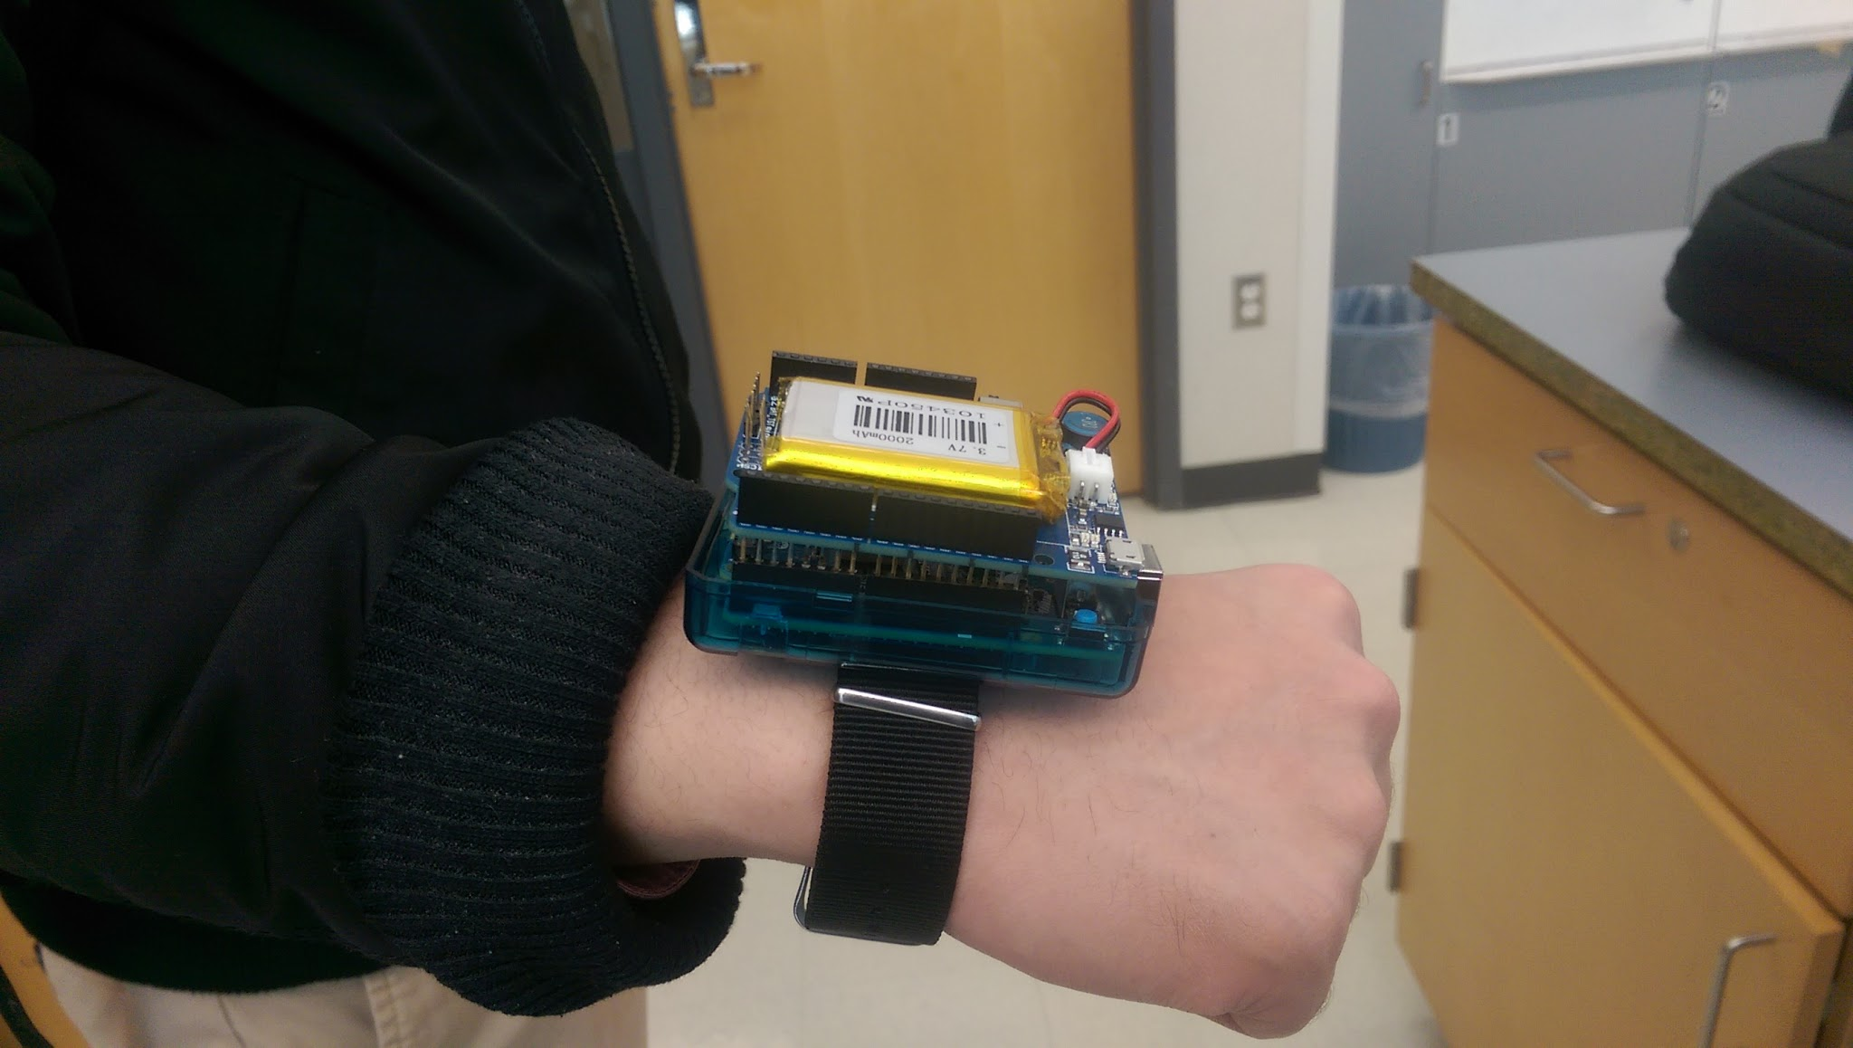

*Figure 19: The wearable design (fitted with the battery and strap)*

**5.0 Conclusions**

5.1 **Overall**

The validation of all testing conditions during the end-to-end demonstration proves that the design choice implemented - the session control, selection procedure, gesture implementation, database interaction - appropriately satisfies all the client requirements of the given product. The Luminesense system changes the method in which humans interact with lighting fixtures. The solution provided allows for an alternate energy efficient paradigm for smart lighting systems.

5.2 **Luminaire Selection**

Conditions for a successful test involve an agreement between the ID’s observed, the selected Luminaires received by the Raspberry Pi and the Luminaire map. This is illustrated below in Figures 20 and 21.









*Figure 20: selected Luminaire ID’s*



*Figure 21: Luminaire map*

5.3 **Gesture Mode**

Conditions for a successful test involve an agreement between the light fixture before and after the light fixture arrangement concluding the session, and the gesture return data. This is illustrated below in Figures 22, 23, and 24.

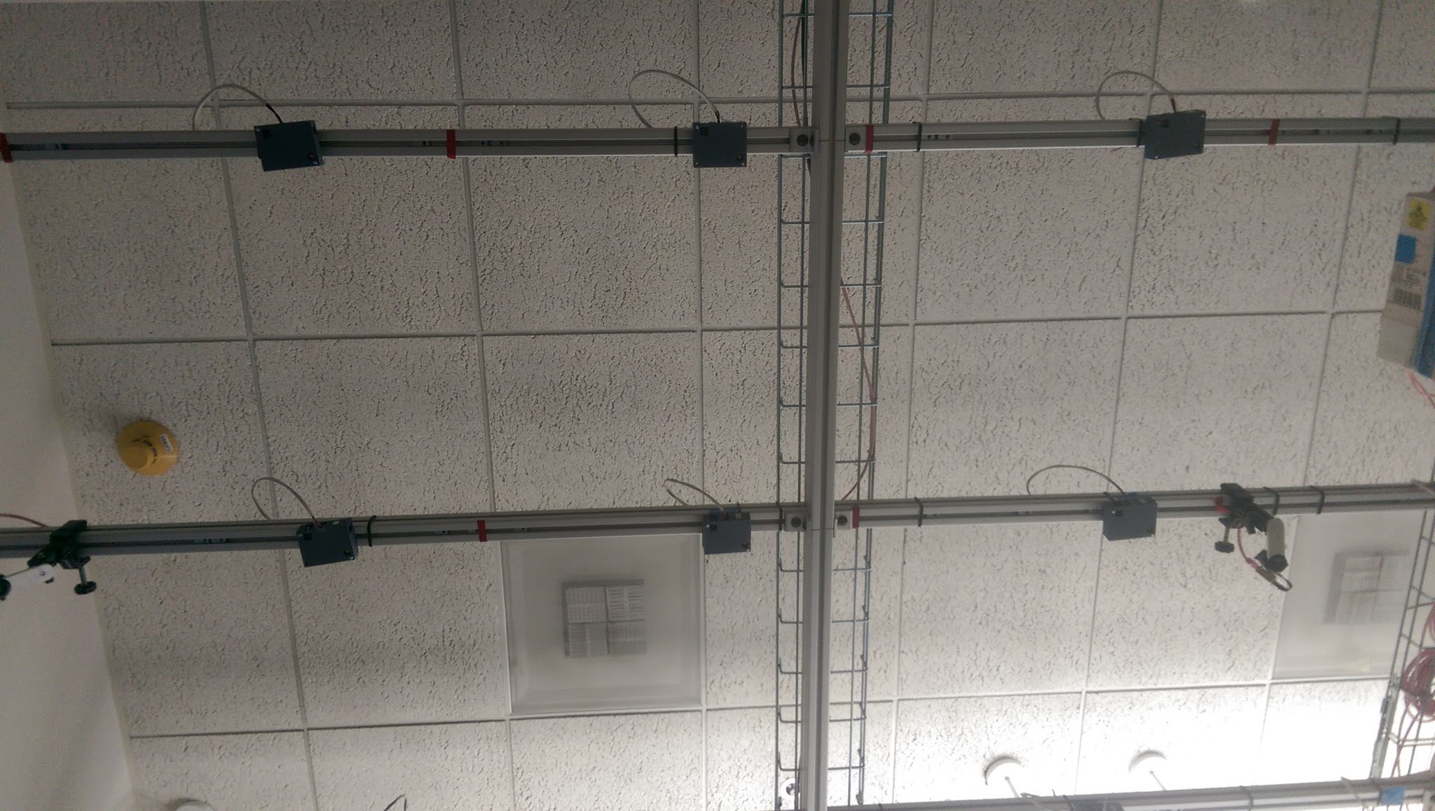

*Figure 22: Light fixture before*

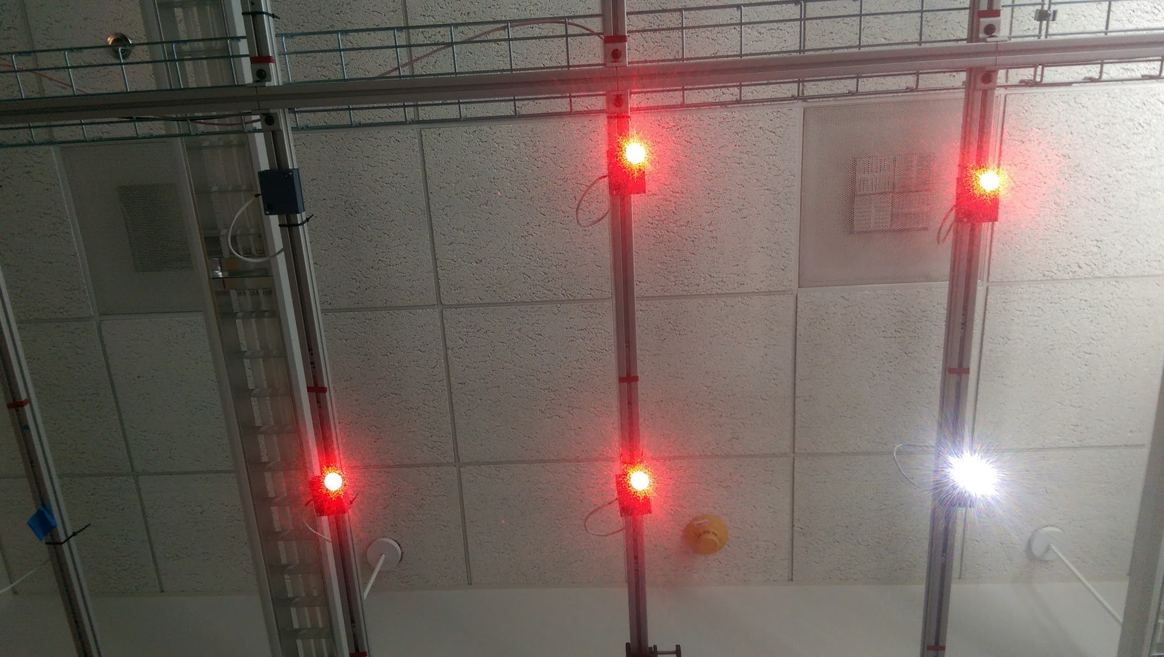

*Figure 23: Light fixture after*

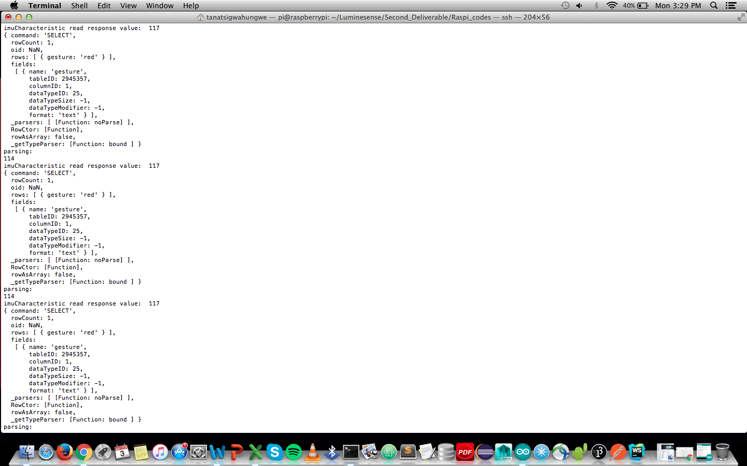

*Figure 24: Gesture command data*

5.4 **Adaptive Mode**

The ability to provide “automatic” control over the system when a wearable is not present was a key customer requirement. The occupancy detection demonstrated in this deliverable is the basis for the autonomous mode. It showed the system recognizing a new entrant, and in contrast recognizing an empty room. These two pieces of information will let our system know when to turn the lights on/off. This functionality highlights the Luminesense system’s ability to respond to passive user input (without direct commands). Future improvements in occupancy detection would be to detect the specific location of the occupant in the room (e.g. which sensor they are standing under). Additionally, the capacity to run occupancy detection for extended periods of time (hours) is necessary before installation can be successful.

5.5 **Website Application**

The website application provides the user with an additional method for interacting with the luminesense system, including viewing energy usage, issuing commands, and customizing their gesture preferences. Therefore, this part of the design satisfies key customer requirements including being able to track energy consumption and customizing gestures. It also solves a major design flaw that was brought up early on in the project, which is how the user can control their system if their wearable is nonfunctional. Future improvements to the web application would include aesthetic improvements as well as a way for users to login, in order to support multiple luminesense systems.

5.6 **Wearable Design**

The battery life is reasonably long for daily use as a wearable device and requires only three hours to charge the battery from zero to fully charged. During the functional test, the battery helps the wearable device in the project to be portable instead of relying on the cable connecting the board to a PC for power. Furthermore, the case allows for more accessible selection of luminaires and implementation of gestures on the selected luminaires.

5.7 **Coda and Future Work**

The data presented prior to and on the day of testing implies that the implementation of the test design is successful. Future, more complex iterations of the design will build upon the architecture of this design. For example, implementing a PCB design to integrate the amplifier circuit, and additional peripherals. The integration of subsequent design features will be further discussed in immediate future design reviews.